Lab09
Yi Han
Kemal Dilsiz

We added the shifter into datapath and put an extra input to ALU.

ALU result is decided with a mux4 like the picture below.

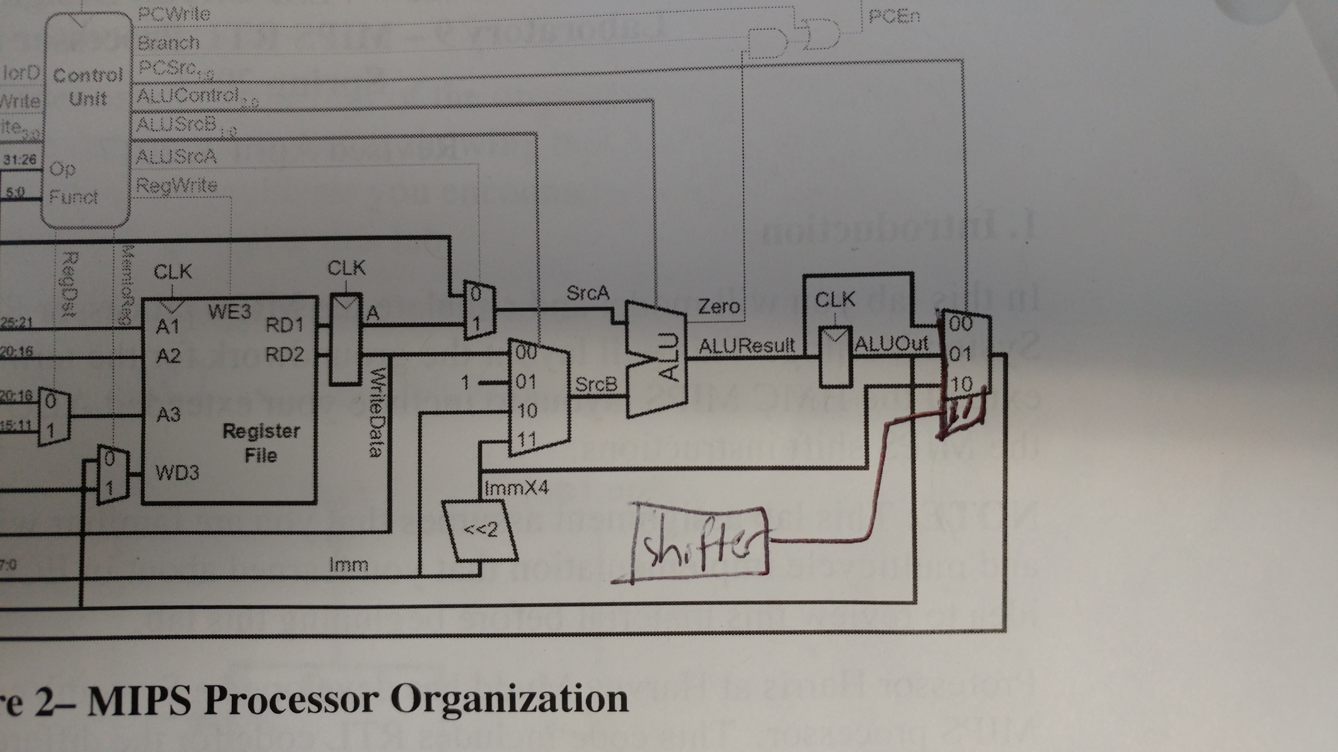
The input of the shifter is the instr[11:15] because that is the part which is being shifted.

Shamt comes from instr[16:21]. Right and Aith are decided according to the funct in datapath module as you can also see in our system verilog tar folder.

Below is the simulation successfully completed.

Requirements for the successful simulation are the same because we have tested xor, nor, sll, srl, and sra with commands that would not change the output.



